

Table of Contents

Pharmaceutical Web Automation Testing 2

Prerequisite 2

JDK (v1.8) or Greater Version 2

Download Link: 2

Steps for Download: 2

Steps for installation 6

Maven (v3.8.1) or Greater Version 15

Download Link: 15

Steps for Download: 15

Steps for installation 16

Allure (v2.13.5) or Greater Version 22

Download Link: 22

Steps for Download: 22

Steps for installation 23

Eclips (v4.22.0) 25

Download Link: 25

Steps for Download: 25

Steps for installation 26

Open and run the Test Cases 29

Steps for open and run Test Cases 29

Generate Automation Test Report 31

Steps for Generate Test Report 31

Pharmaceutical Web Automation Testing

# Prerequisite

## JDK (v1.8) or Greater Version

### Download Link:

<https://www.oracle.com/java/technologies/javase/javase8u211-later-archive-downloads.html>

### Steps for Download:

1. Open the Link.
2. Scroll Down the Page.

**Step 1:**

Select the Last JDK from the “Java SE Development Kit 8u331” Table. (See Below Screenshot)

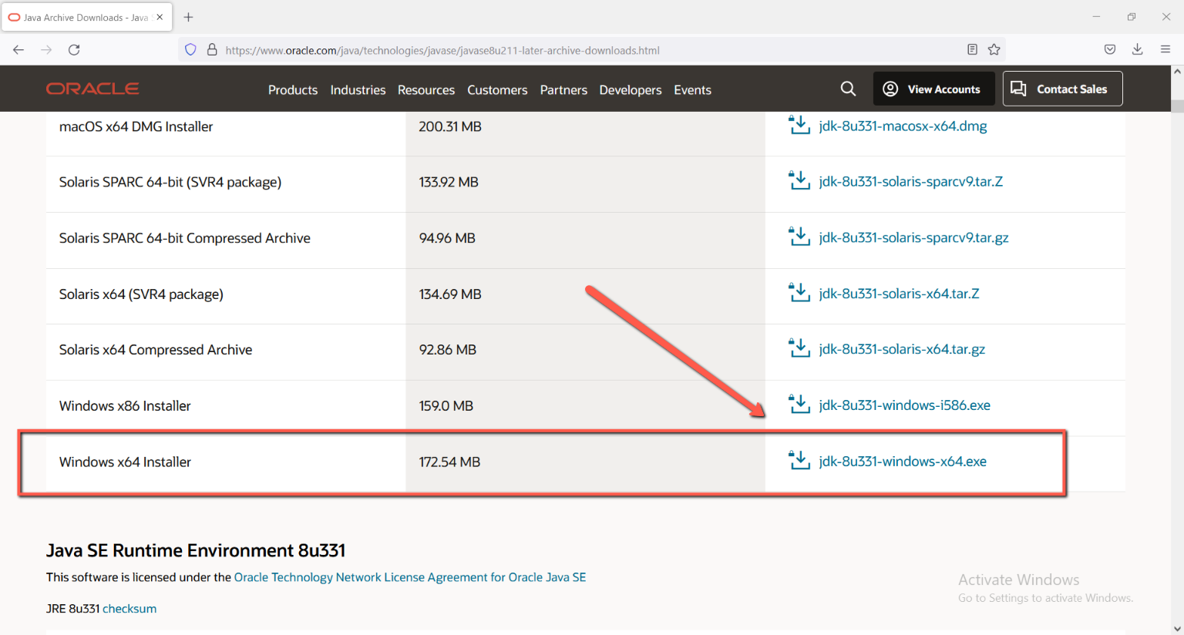

**Step 2:**

Click on Download button.

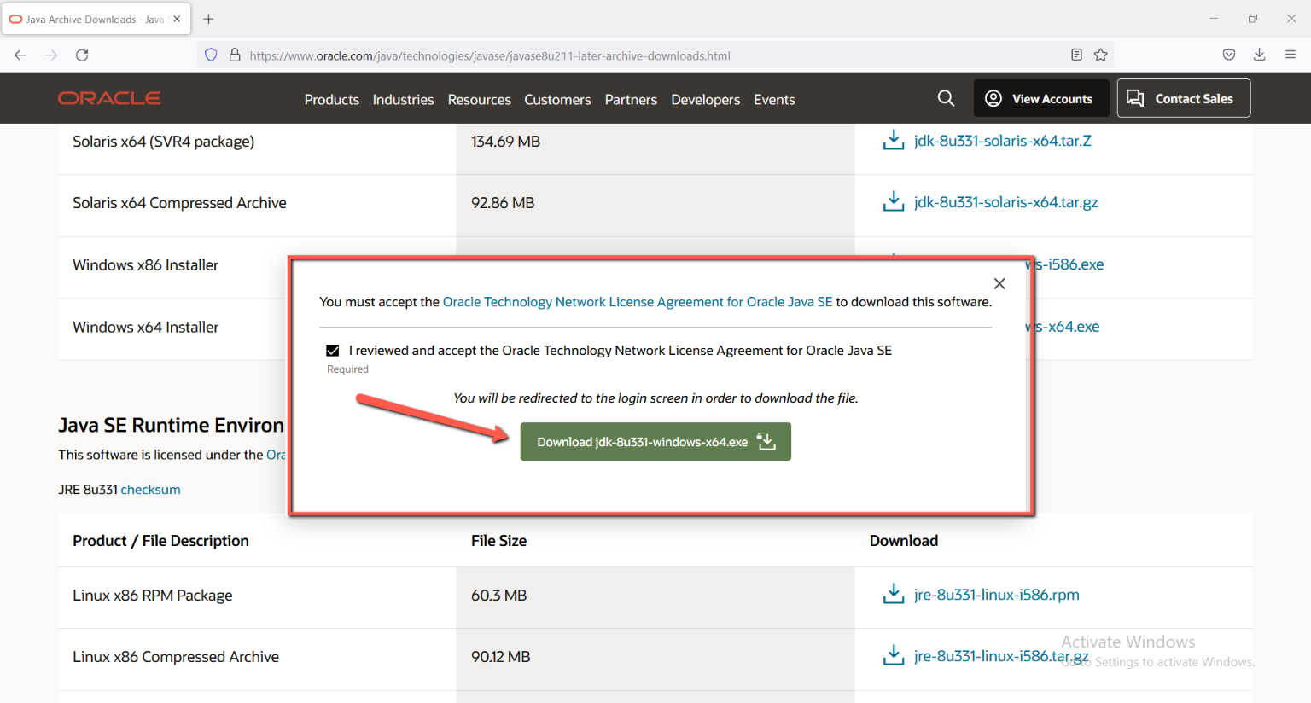

**Step 3:**

Click on create account button.

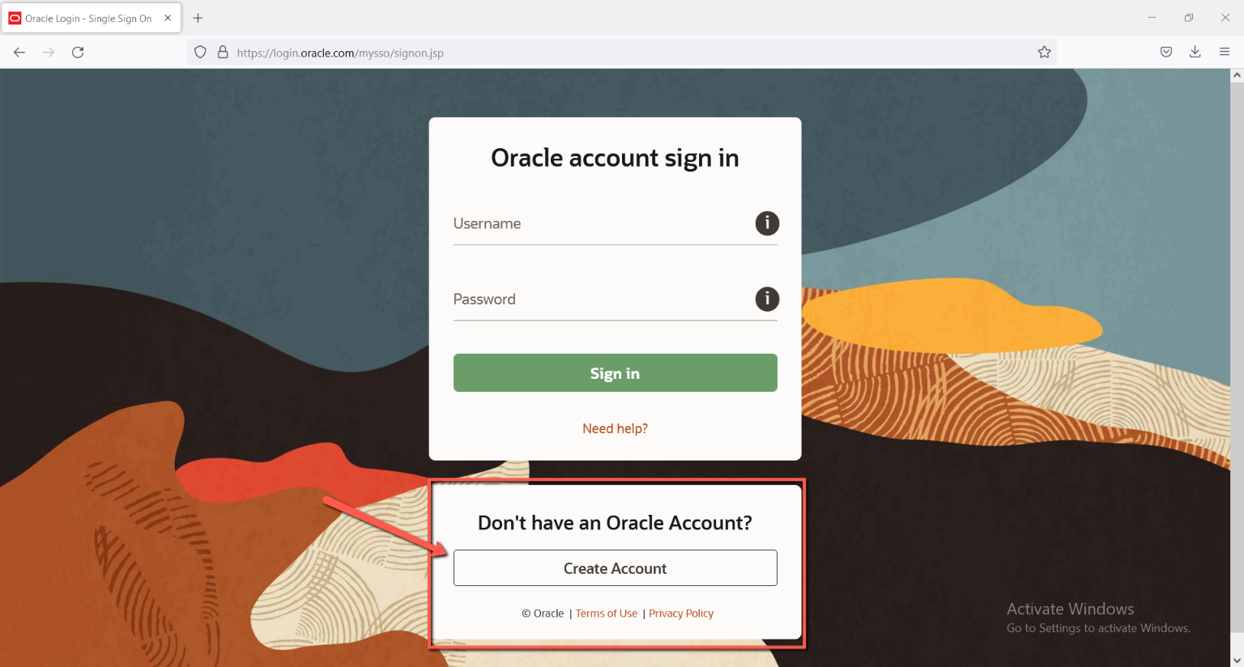

**Step 4:**

Fill out the form and Click on Create account button.

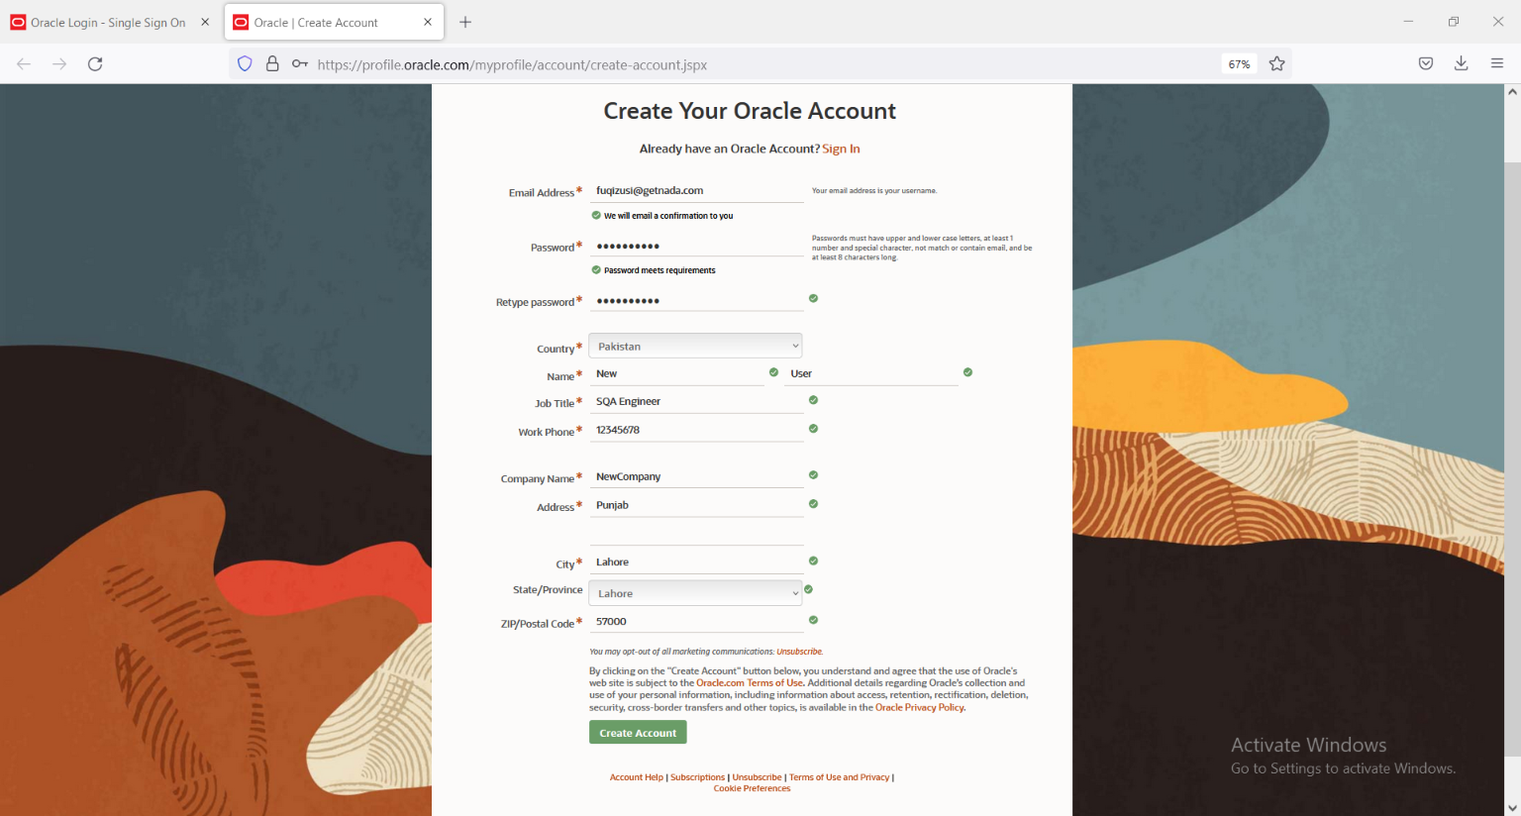

**Step 5:**

Check and verify your email.

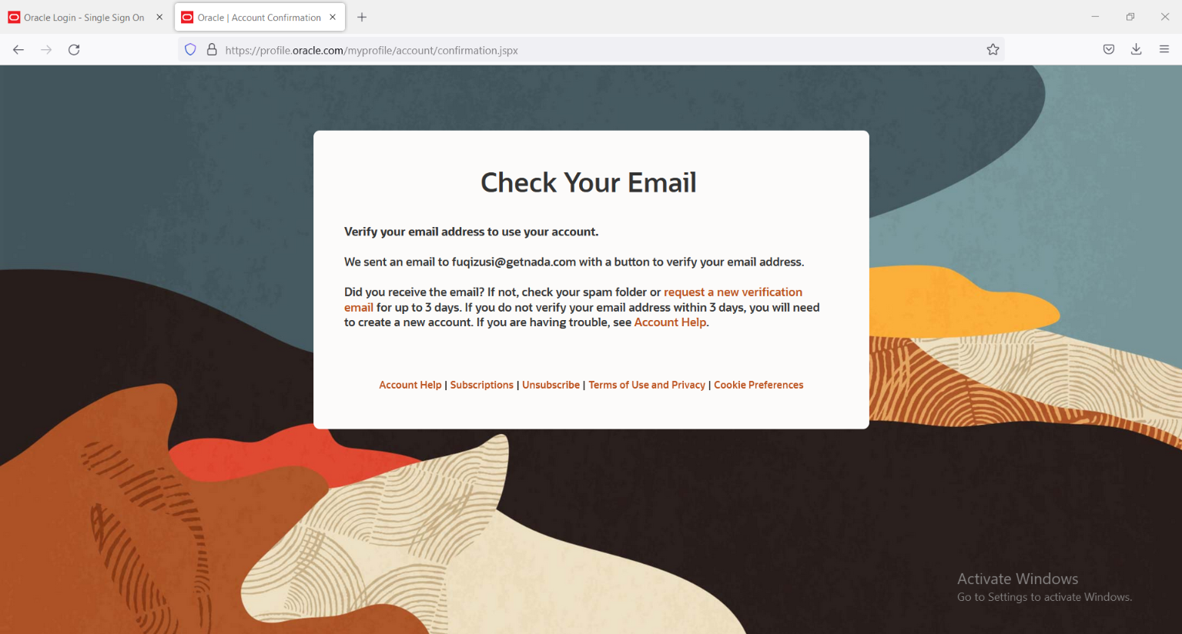

**Step 6:**

After verification, you can see this page (in below image) Click on Continue. And then close this page and move back on the login page.

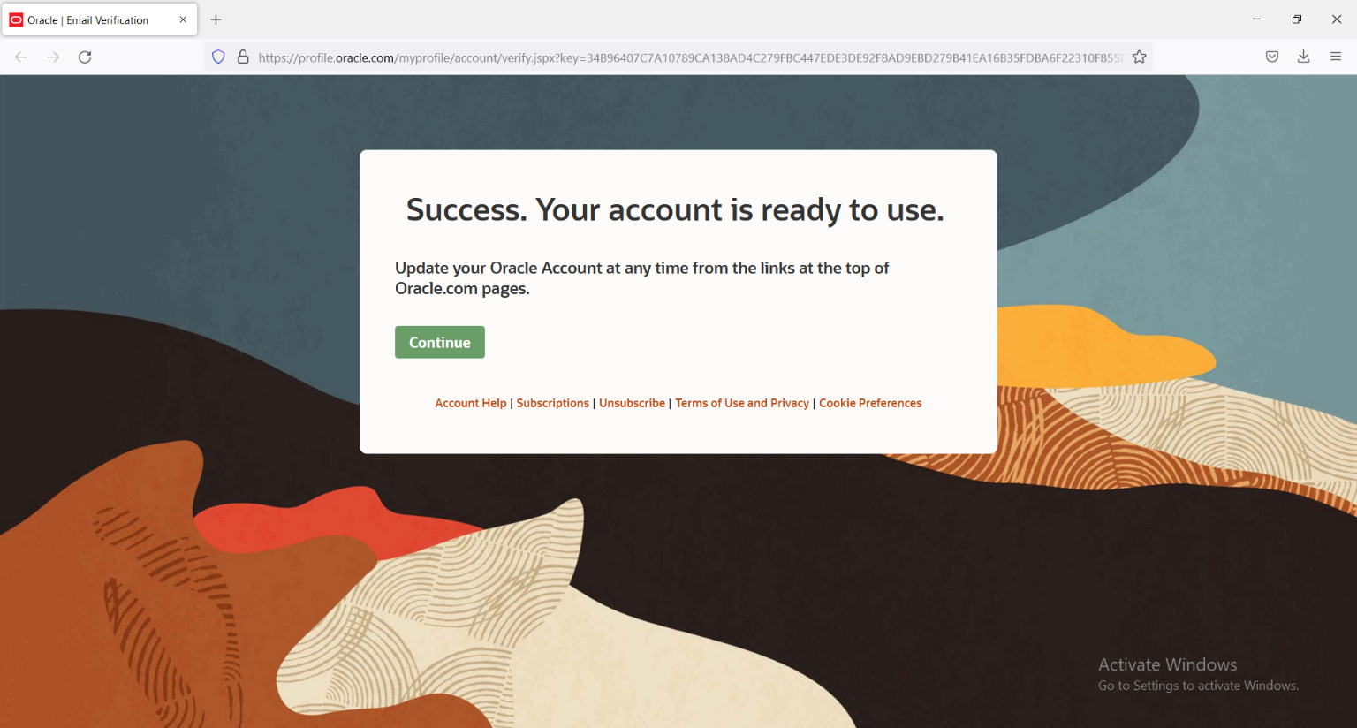

**Step 7:**

Enter valid email and password. Then click on Sign in.

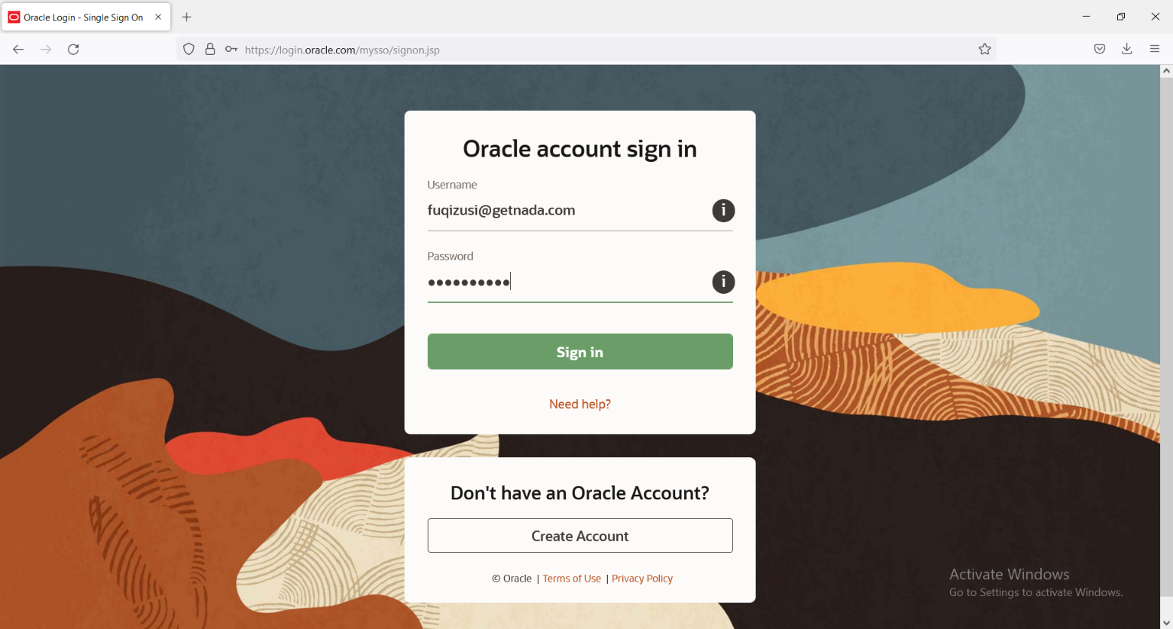

**Step 8:**

JDK automatically download after Sign in, and you can see in your download folder.

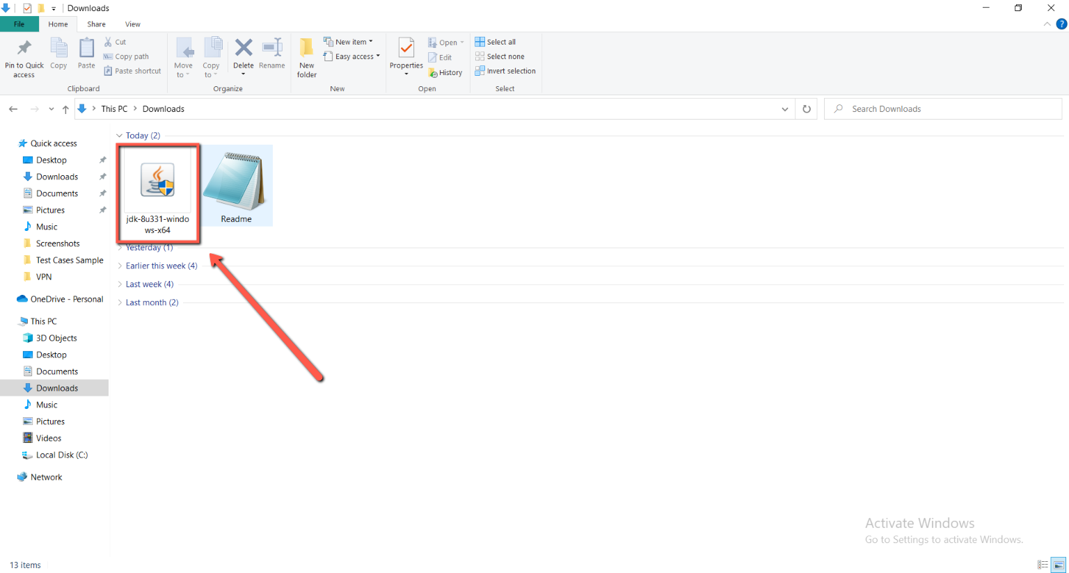

### Steps for installation

**Step 1:**

Right click from the mouse on the JDK application and select the option “Run as administrator”.

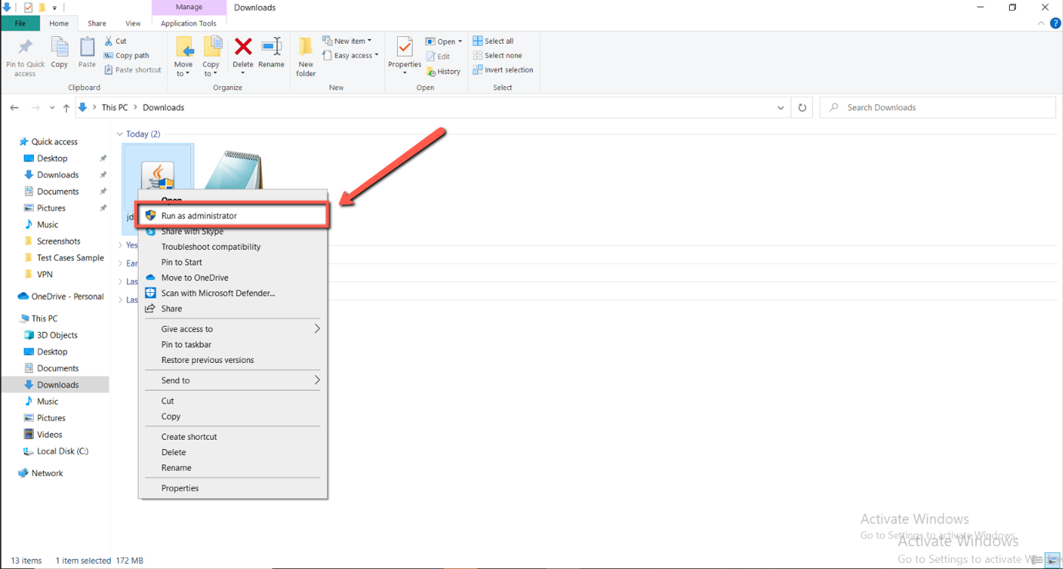

**Step 2:**

Click on “Yes”.

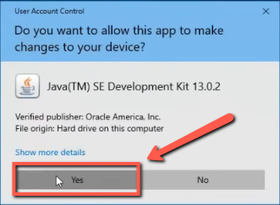

**Step 3:**

Click on “Next”.

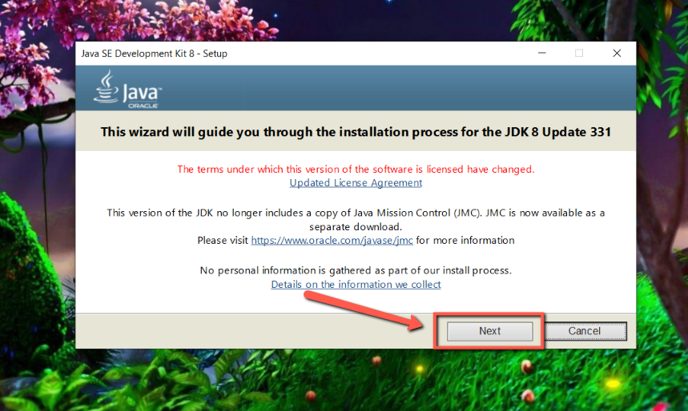

**Step 4:**

Click on “Next”.

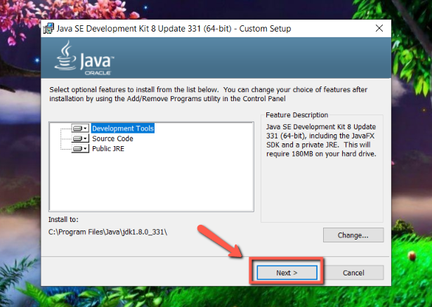

**Step 5:**

Wait few mints.

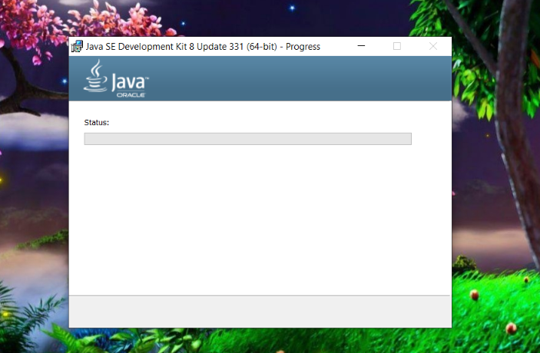

**Step 6:**

Click on Next.

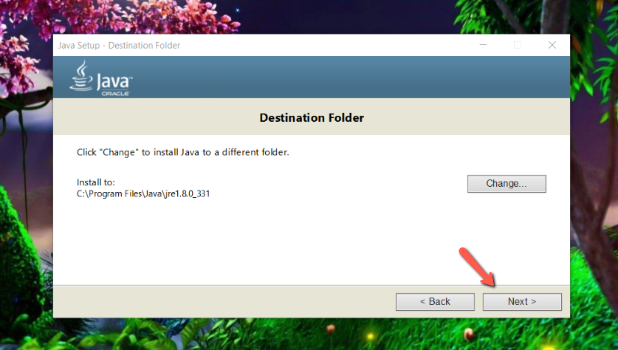

**Step 7:**

Click on Close.

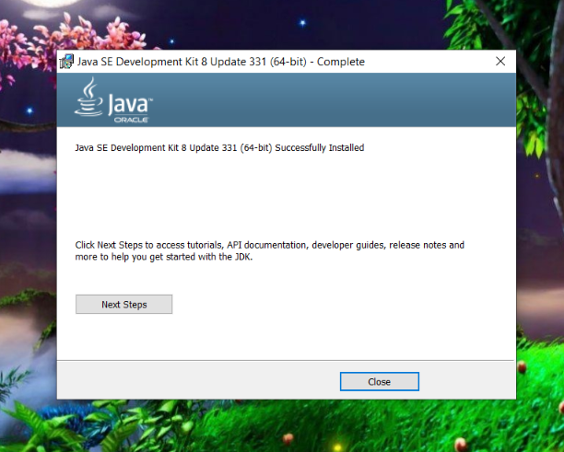

**Step 8:**

Double click on My computer or right click on my computer icon and choose open, then double-click on the C drive. And then click on the program files.

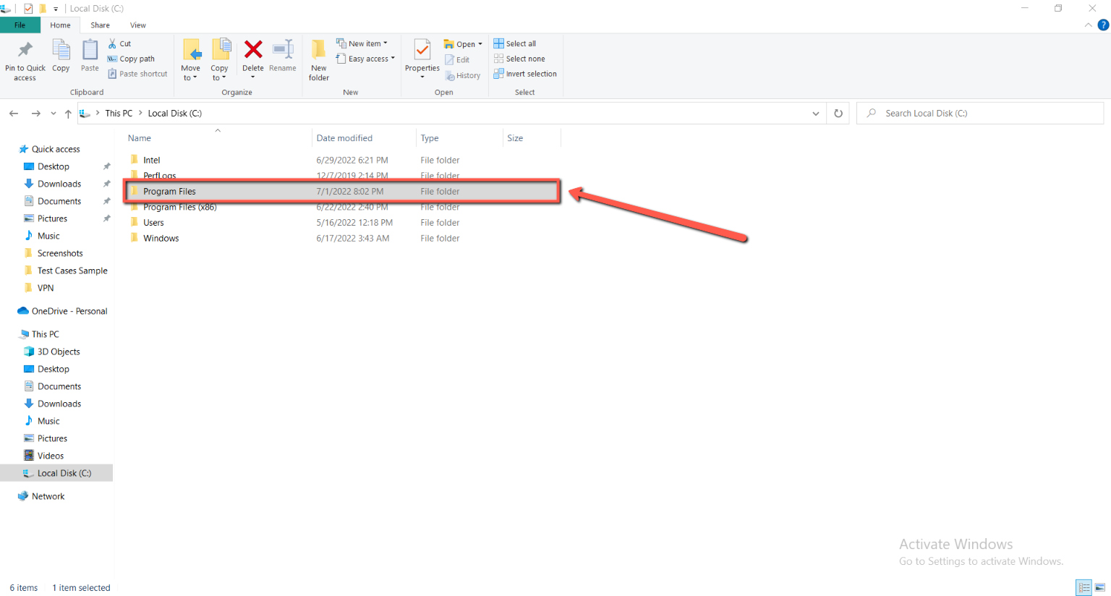

**Step 9:**

Double click on the java folder.

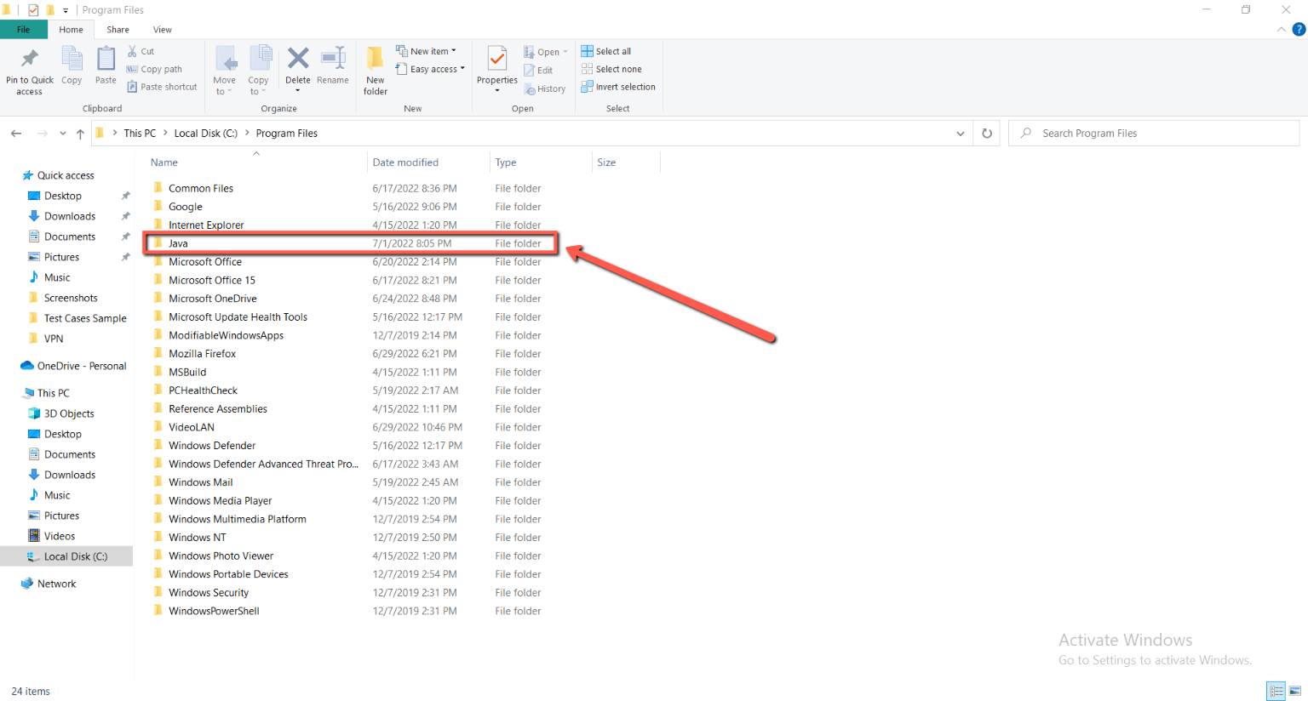

**Step 10:**

Double click on JDK folder.

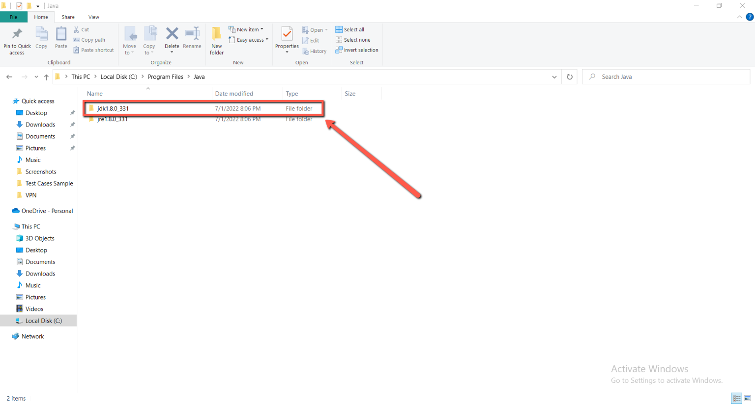

**Step 11:**

Double click on bin folder.

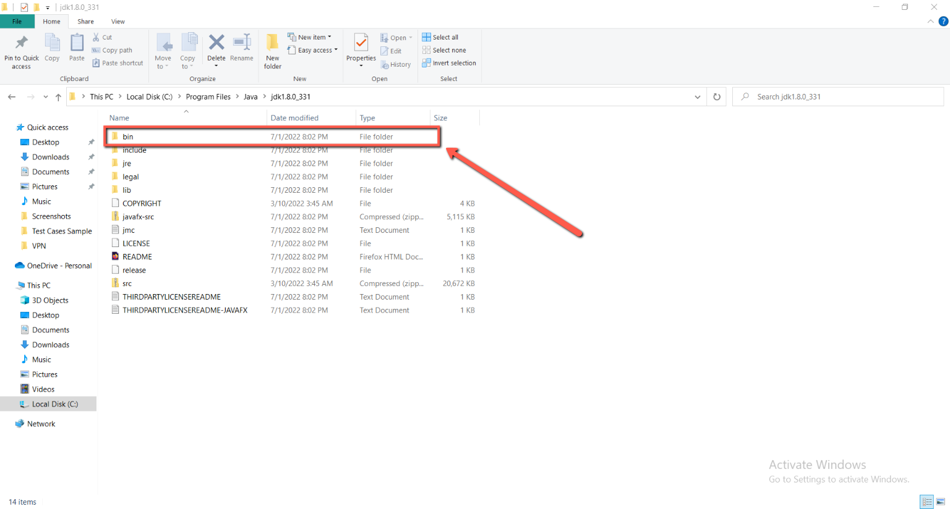

**Step 12:**

Click on the above (appears the folders name) and copy the path.

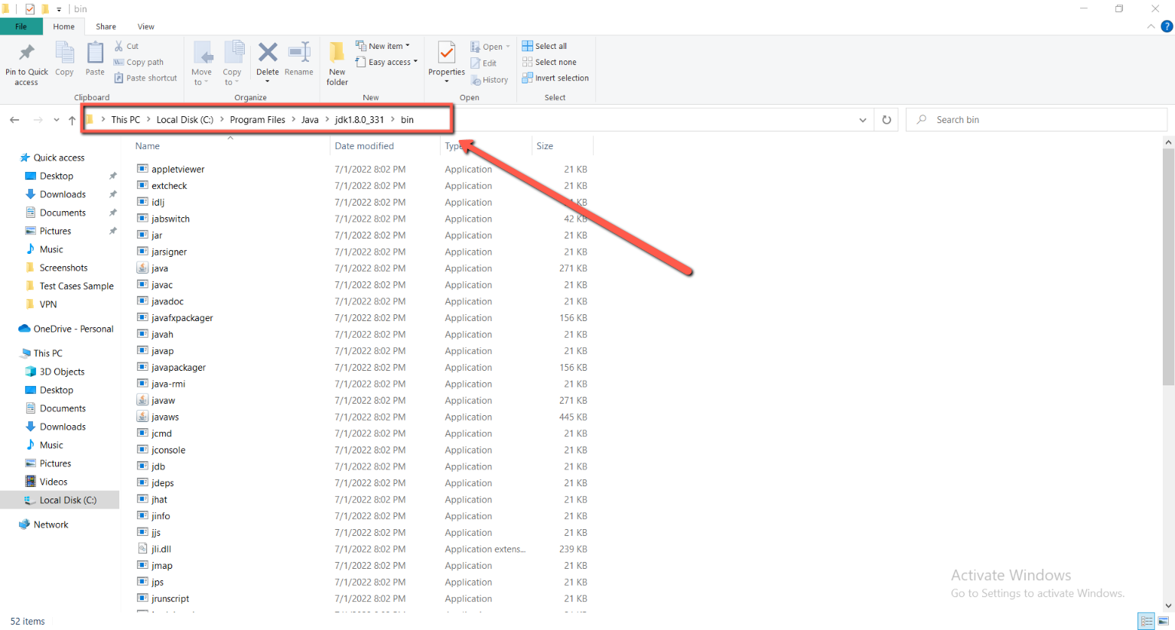

**Step 13:**

Copy this path.

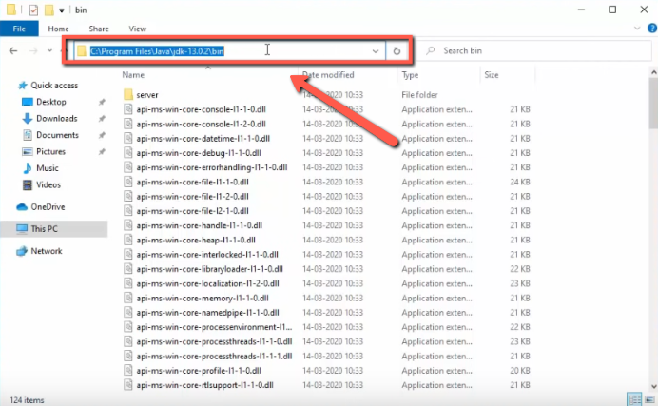

**Step 14:**

Open settings and type “environment” and select the second option.

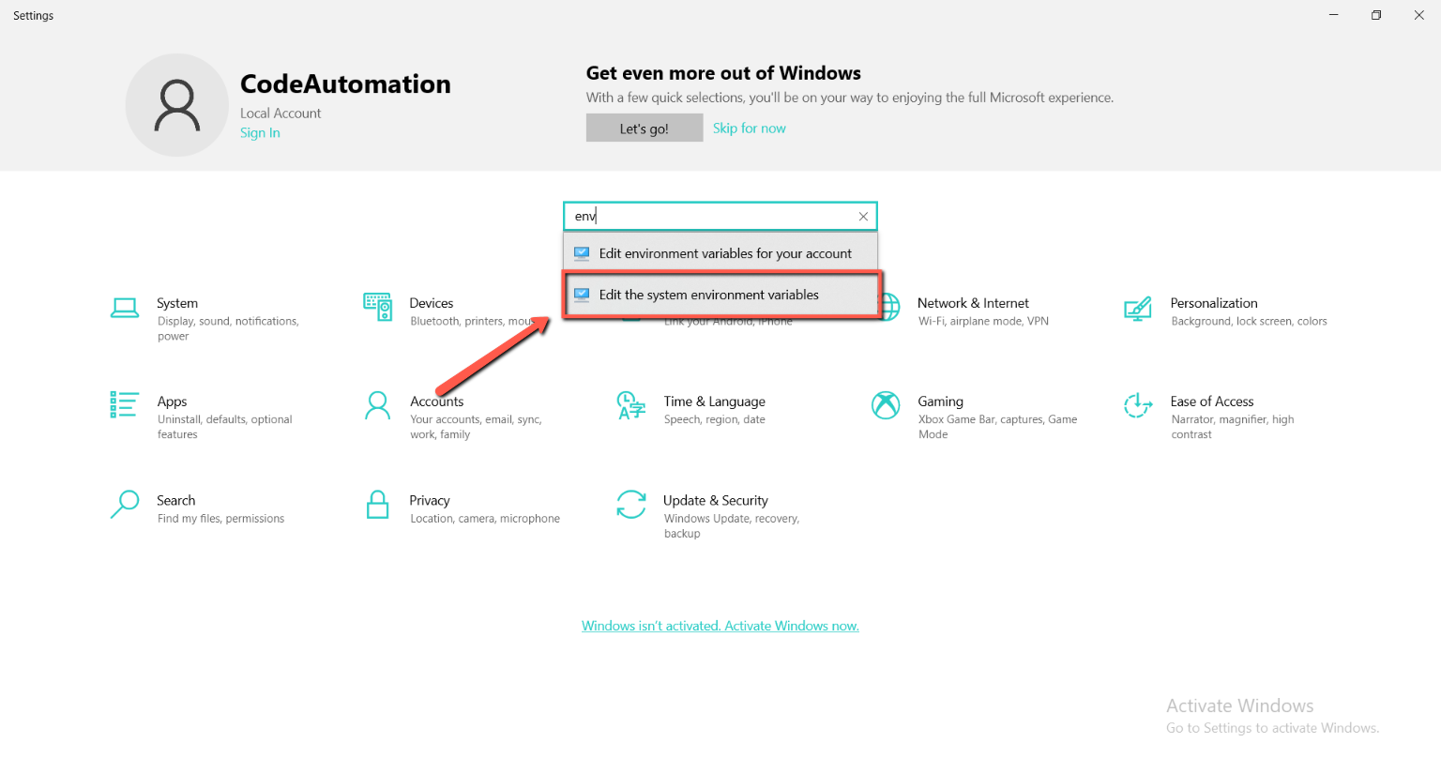

**Step 15:**

Click on Environment variable.

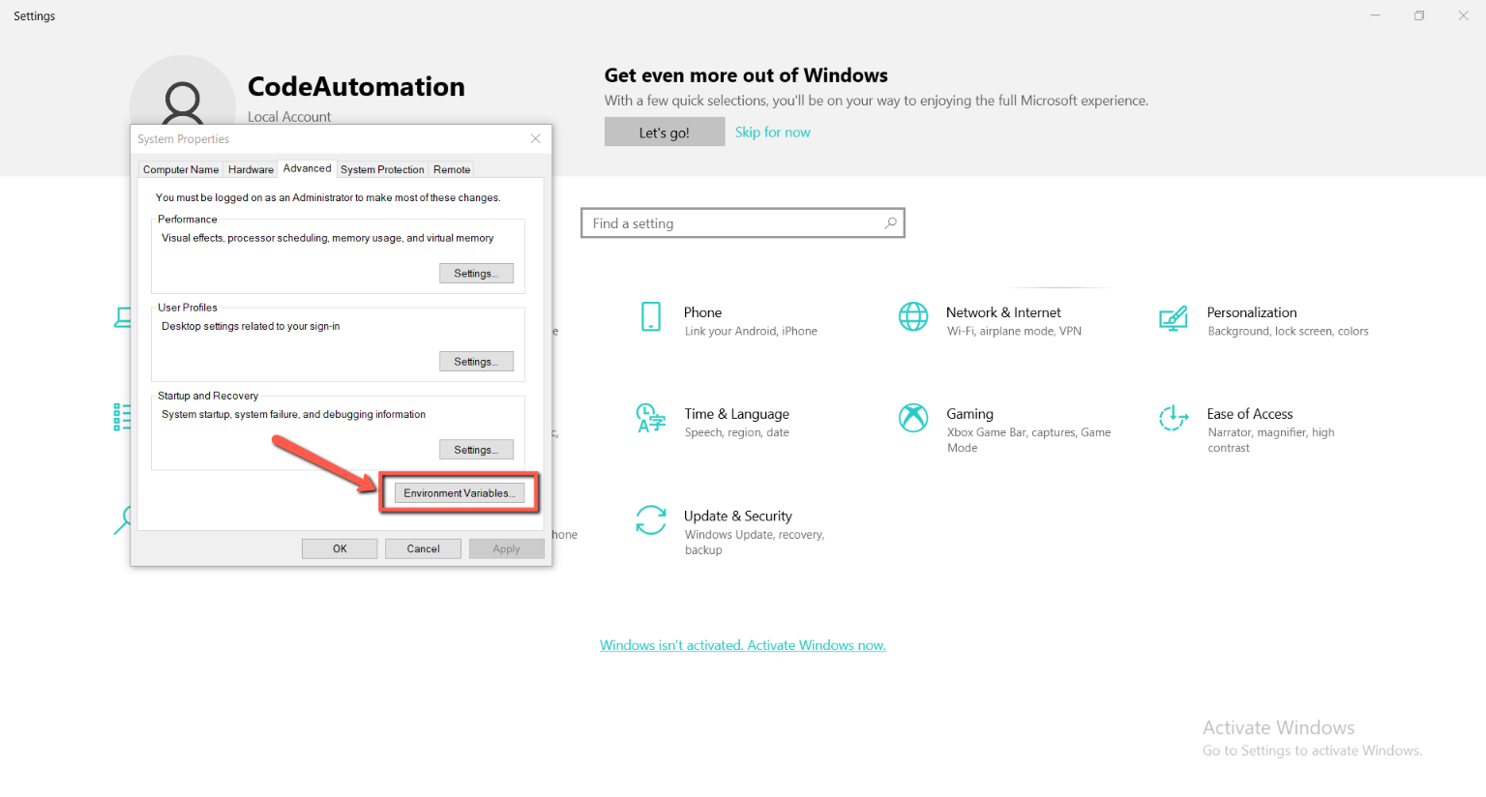

**Step 16:**

Select the path and click on the edit button.

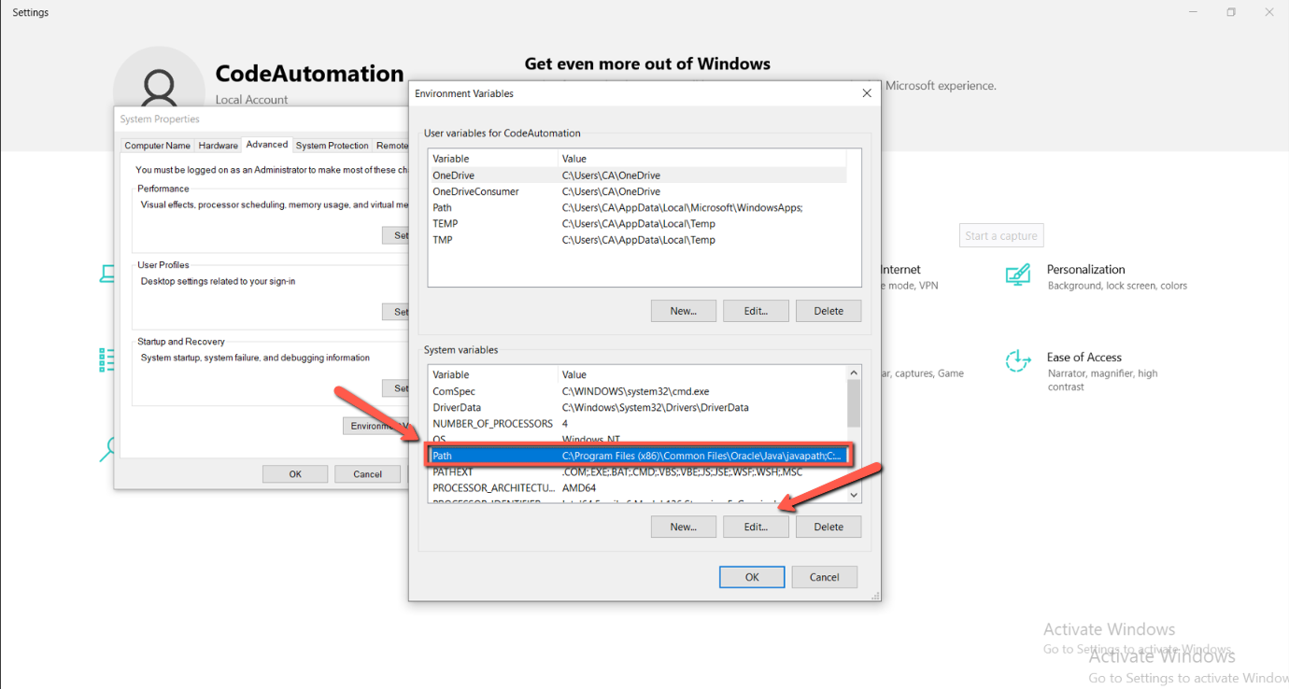

**Step 17:**

Click on new button and paste the copied link of the JDK bin and click okay.

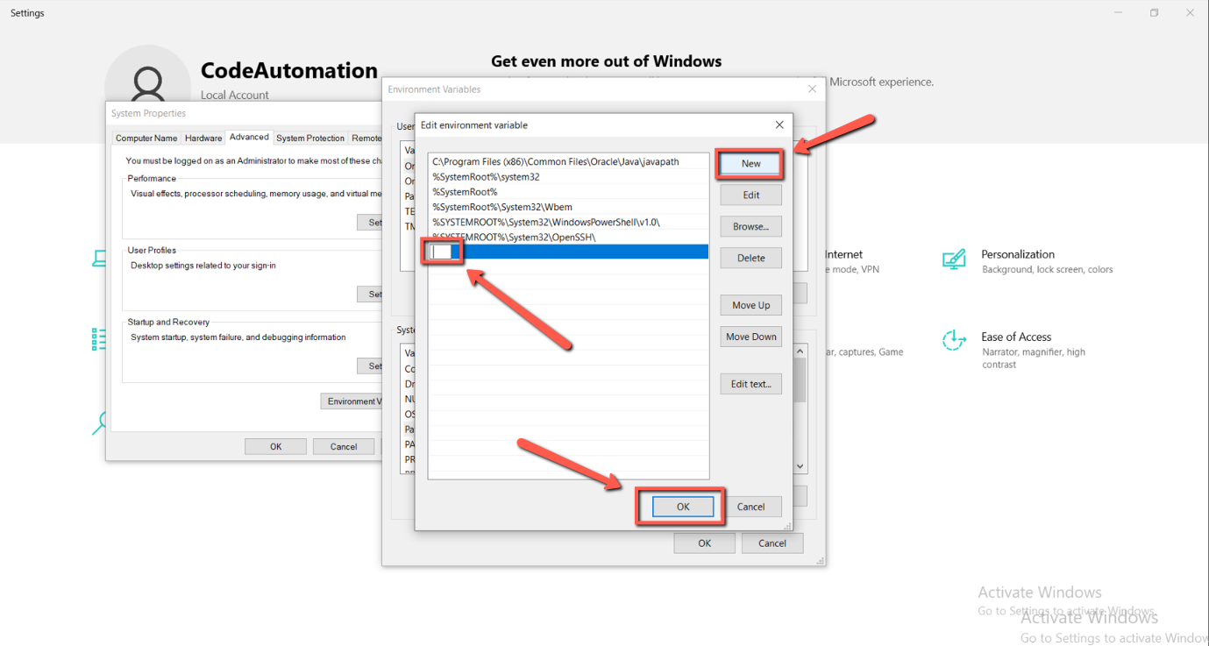

**Step 18: (for check java is install successfully)**

Search “cmd” in the search bar of the setting and write ‘java -version’ and press enter.

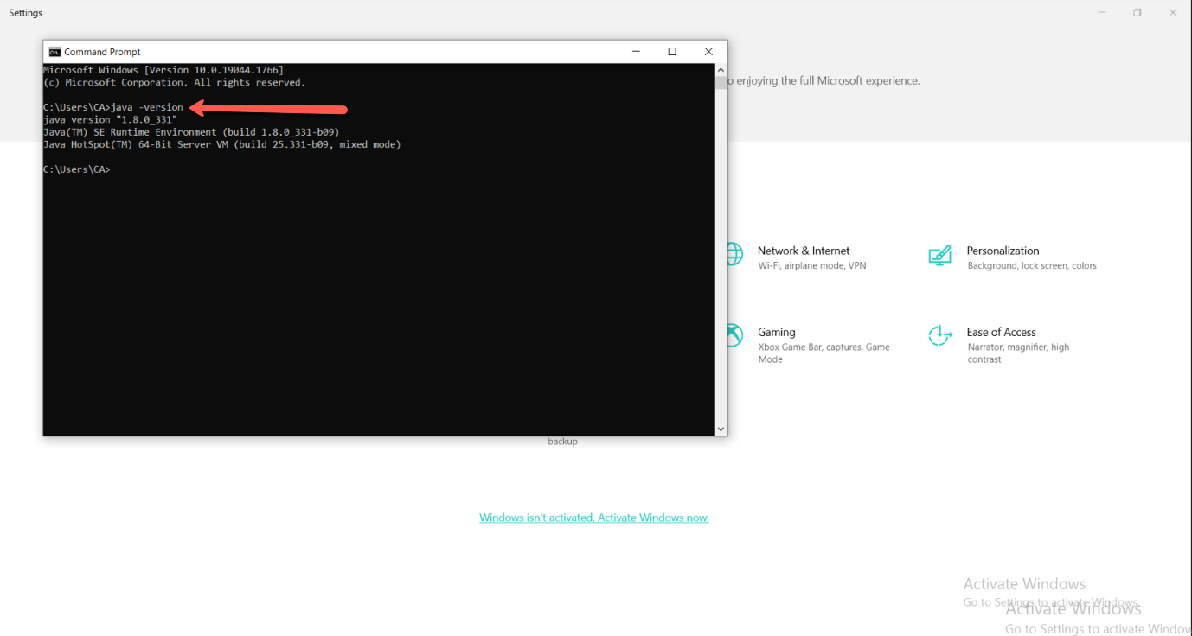

## Maven (v3.8.1) or Greater Version

### Download Link:

<https://maven.apache.org/download.cgi>

### Steps for Download:

1. Open the Link.
2. Scroll Down the Page.
3. Select the second Maven (Binary zip archive) from the table. (See Below Screenshot)

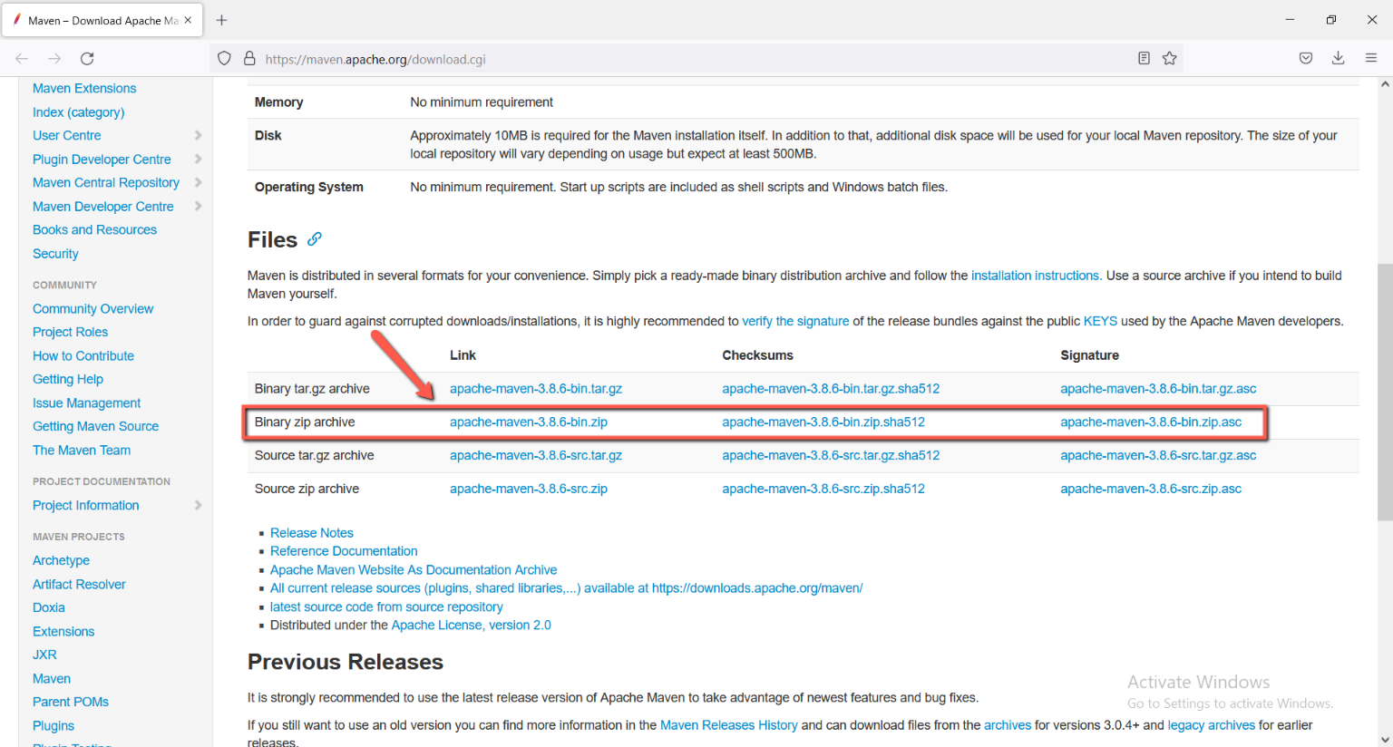

*Figure 2: Download link for the Maven*

### Steps for installation

**Step 1:**

Since there is no installation process, extract the Maven archive to a directory of your choice once the download is complete. For this tutorial, we are using *C:\Program Files\Maven\apache-maven-3.8.4*.

* After downloading the Maven zip file, right-click on the file and click on “extract all”.
* Then go to the C drive and create a folder into the program file folder. Named of that folder is Maven.
* And then paste the extracted folder into this (maven) folder.

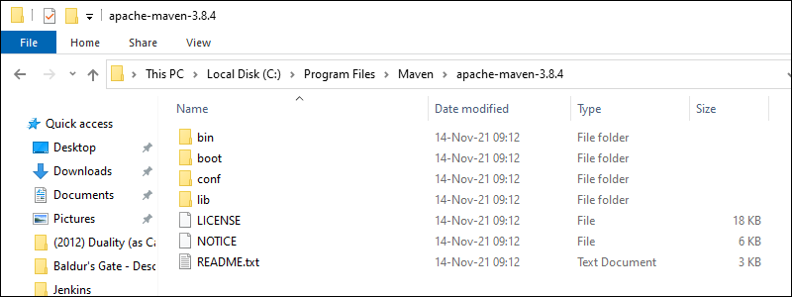

**Step 2:**

* Open the Start menu and search for [environment variables](https://phoenixnap.com/kb/windows-set-environment-variable).
* Click the **Edit the system environment variables** result.

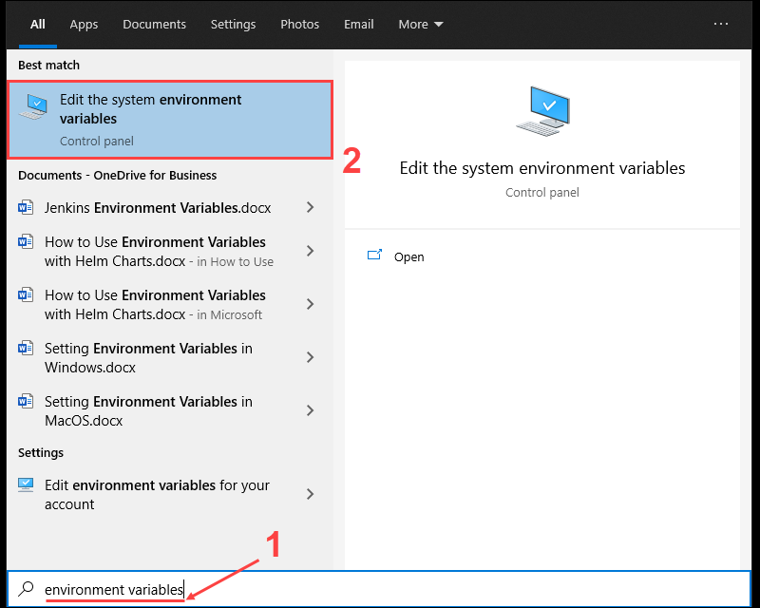

**Step 3:**

Under the Advanced tab *in the* System Properties window, click **Environment Variables.**

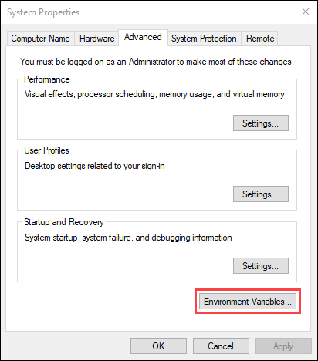

**Step 4:**

Click the **New** button under the *System variables* section to add a new system environment variable.

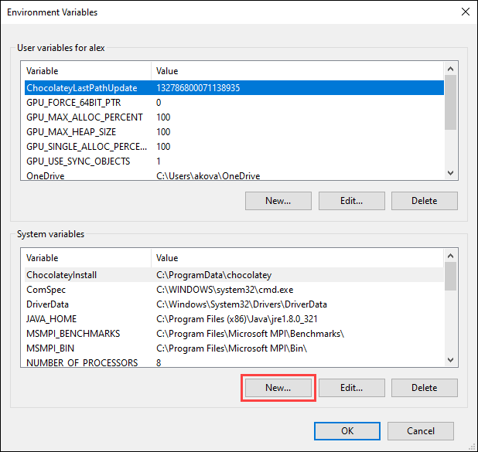

**Step 5:**

Enter **MAVEN_HOME** as the variable name and the path to the Maven directory as the variable value. Click **OK** to save the new system variable.

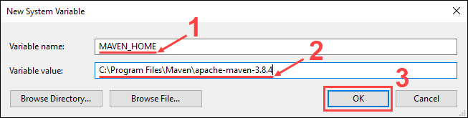

**Step 6:**

Select the **Path** variable under the *System variables* section in the *Environment Variables* window. Click the **Edit** button to edit the variable.

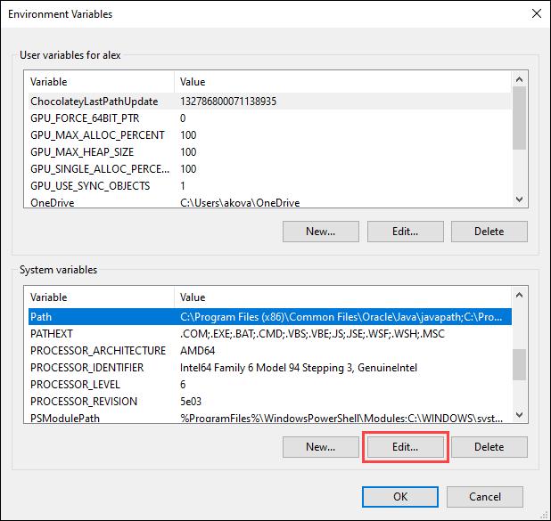

**Step 7:**

Click the **New** button in the *Edit environment variable* window.

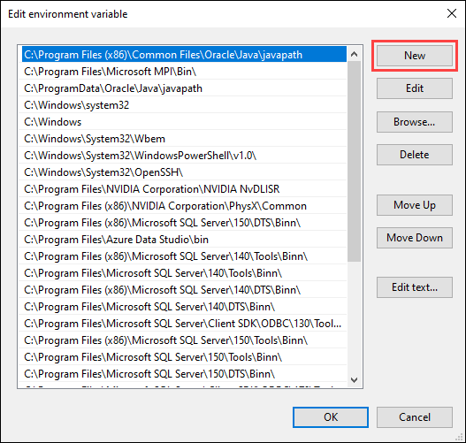

**Step 8:**

Enter **%MAVEN_HOME%\bin** in the new field. Click **OK** to save changes to the **Path** variable.

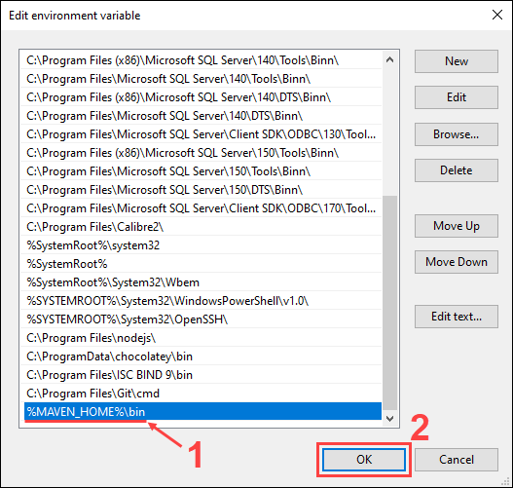

**Step 9:**

Click **OK** in the *Environment Variables* window to save the changes to the system variables.

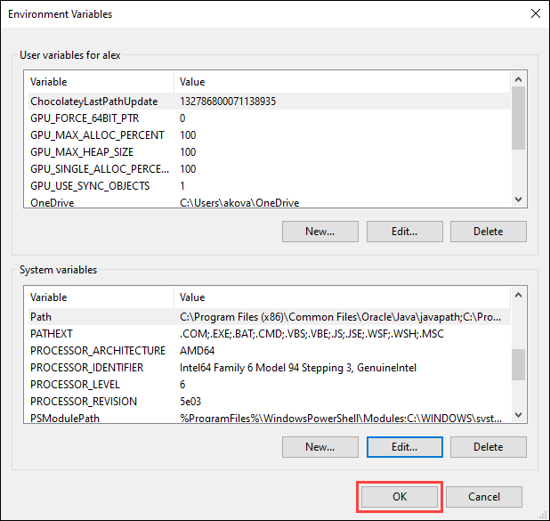

**Step 10:**

(Verify Maven Installation)

In the command prompt, use the following command to verify the installation by checking the current version of Maven: “mvn -version”

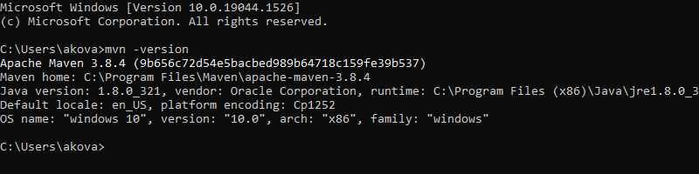

## Allure (v2.13.5) or Greater Version

### Download Link:

<https://github.com/allure-framework/allure2/releases?page=2>

### Steps for Download:

1. Open the Link.
2. Scroll Down the Page.
3. Click on the download from the link’s options. (See Below Screenshot)

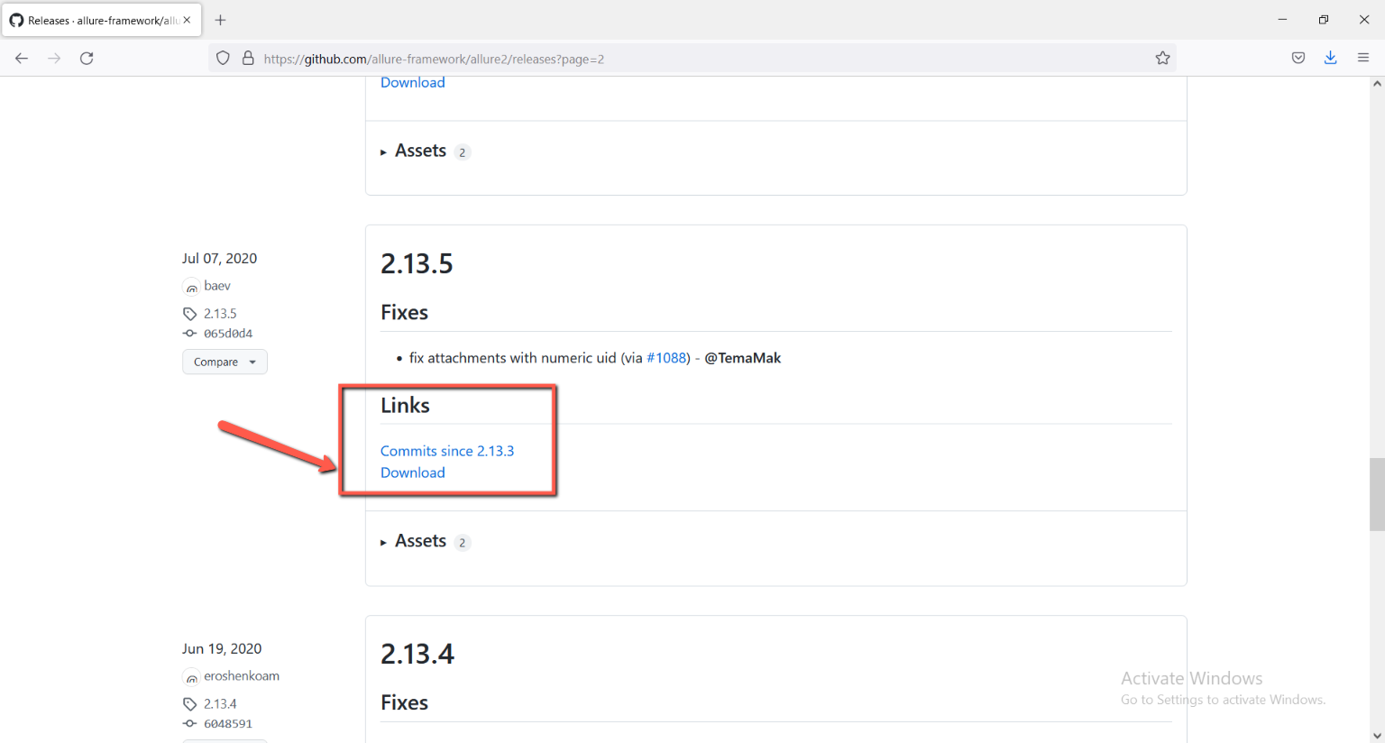

*Figure 3: Download link for Allure*

### Steps for installation

* Extract the download zip file. Then open the C drive 🡪 Program File 🡪 Create folder name Allure and open 🡪 paste extracted folder here.

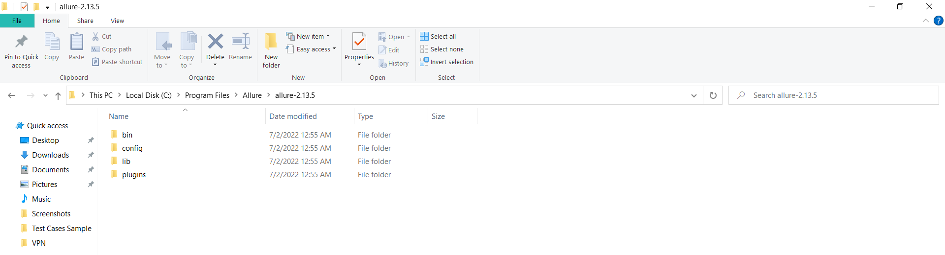

* Double click on Bin folder and copy the path from above.

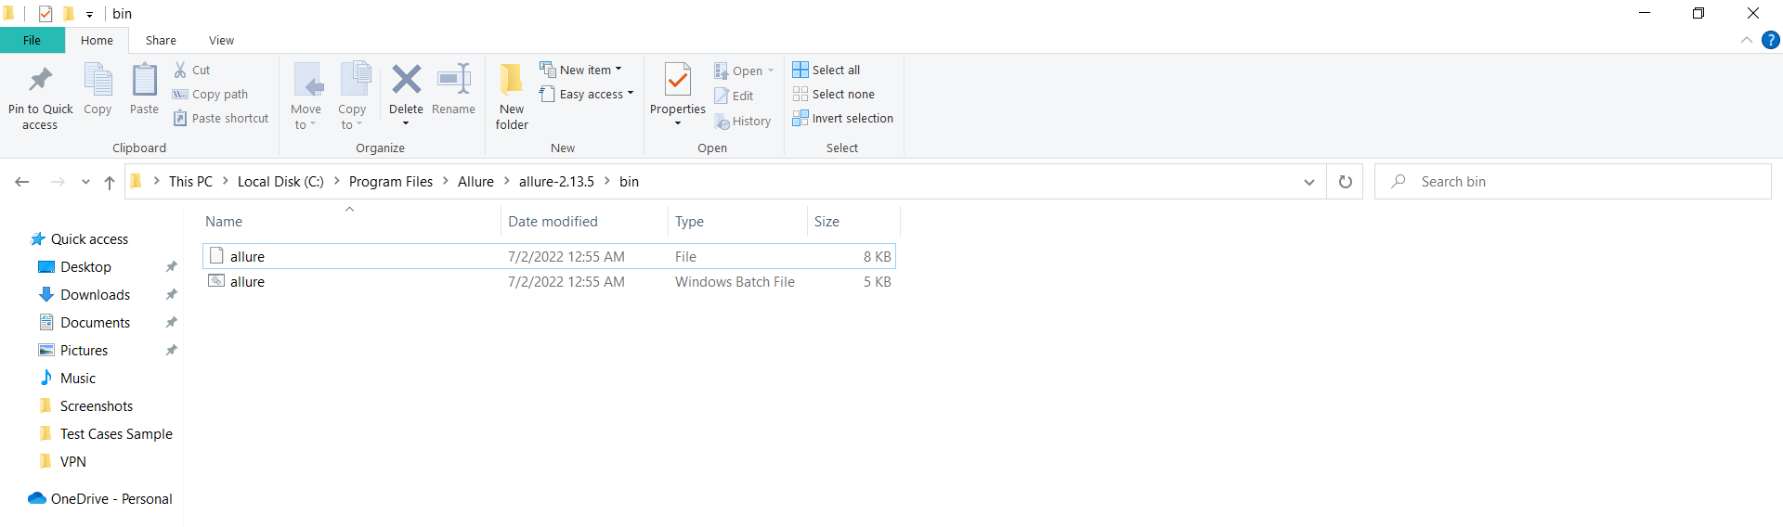

* Open the settings from start button 🡪 search environment variable 🡪 edit environment variables 🡪 click on environment variable from advanced tab 🡪 Click on path 🡪 and click on edit button

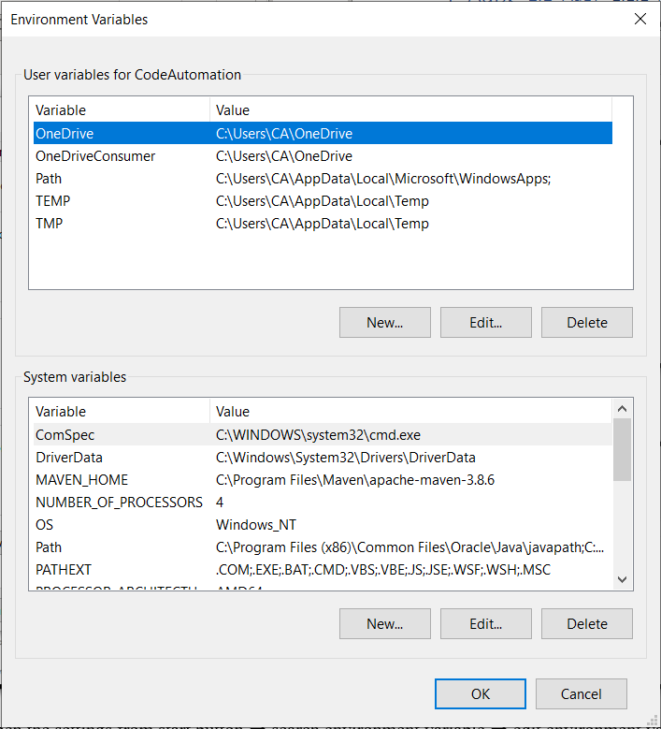

* Click on new and paste the copied path here 🡪click okay.

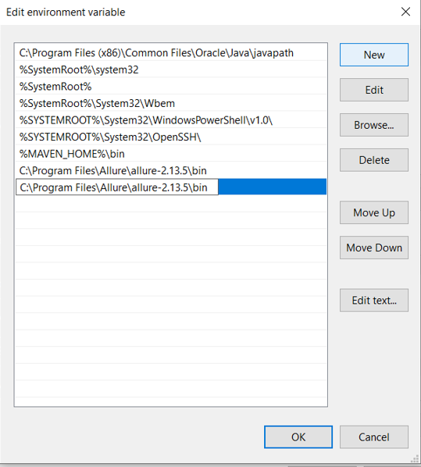

* Verify Allure open cmd and write “allure - -version”

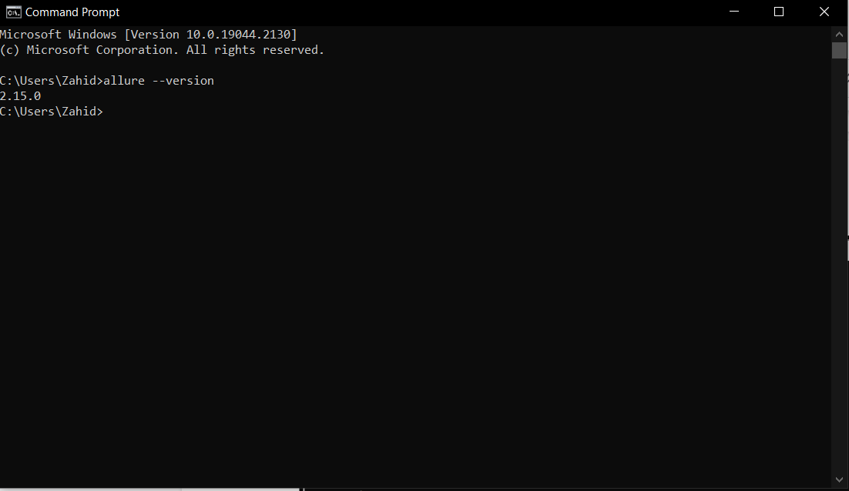

## Eclips (v4.22.0)

### Download Link:

<https://www.eclipse.org/downloads/>

### Steps for Download:

1. Open the Link.
2. Scroll Down the Page.
3. Click on the download x86_64 button. (See Below Screenshot)

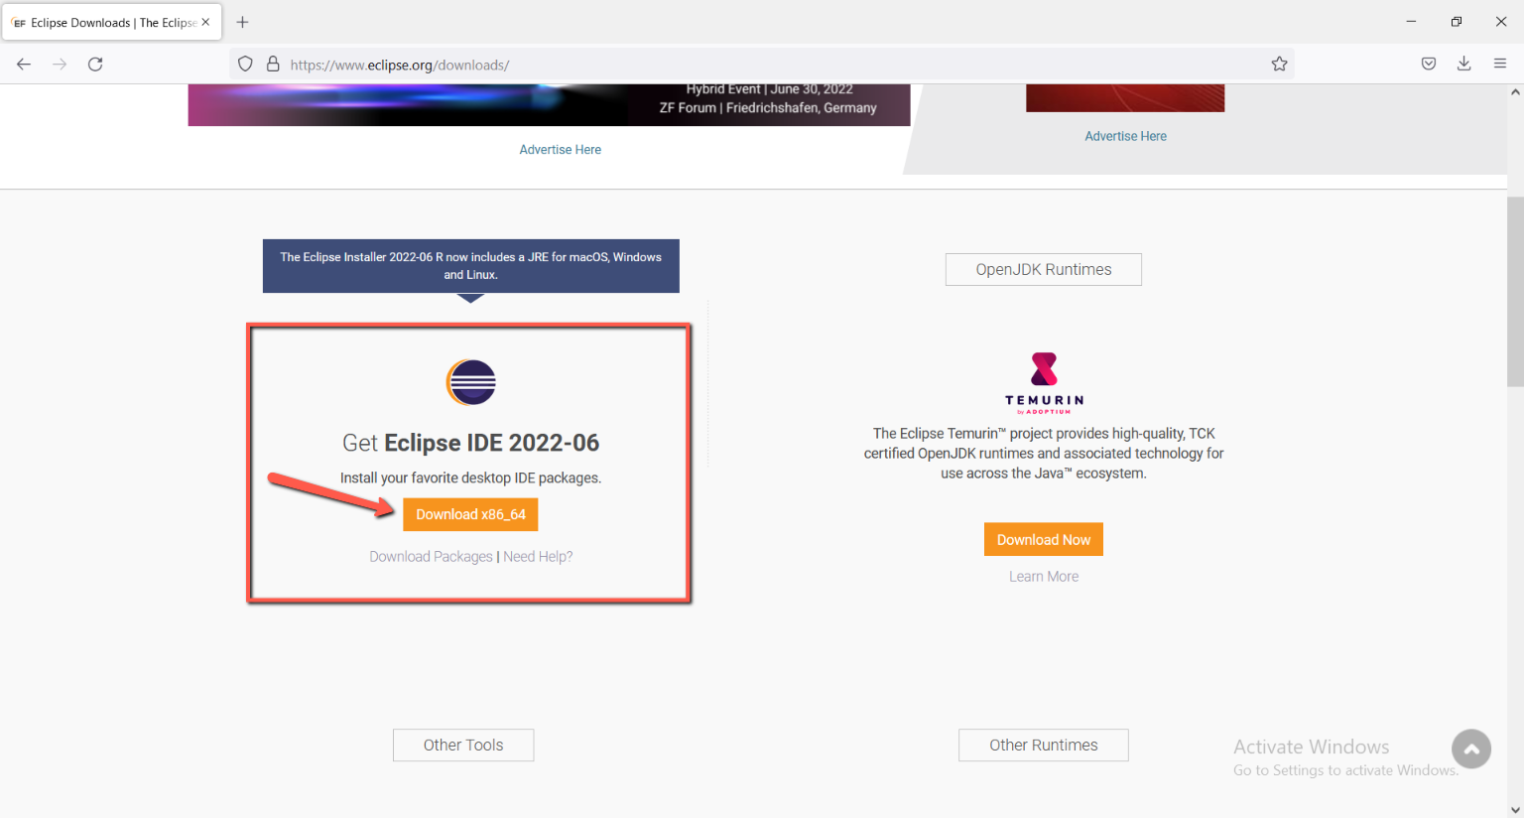

*Figure 4: Download the link for Eclipse*

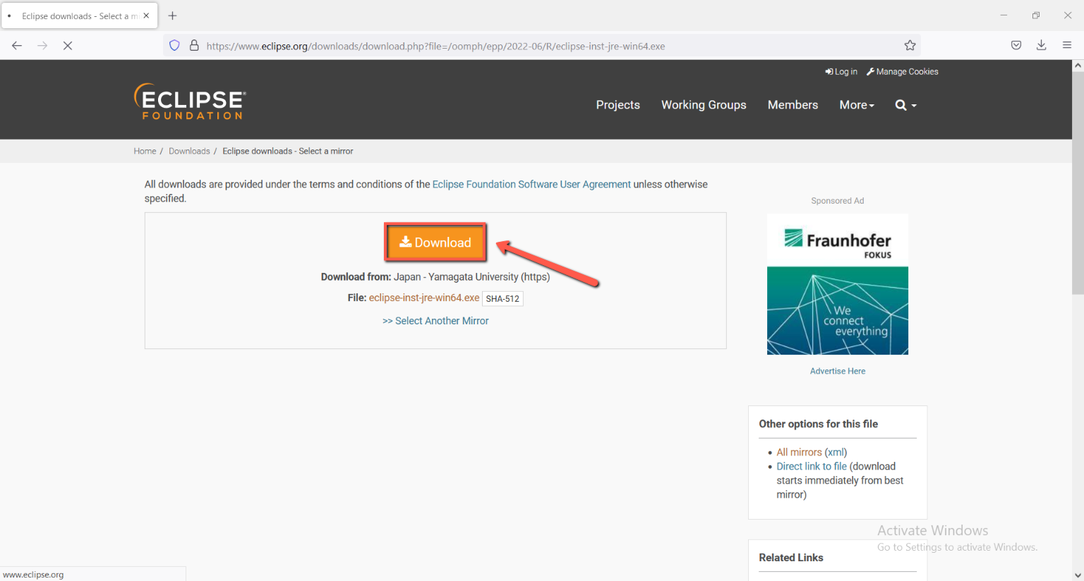

### Steps for installation

**Step 1:**

Click on ‘Eclipse IDE for java Developers’.

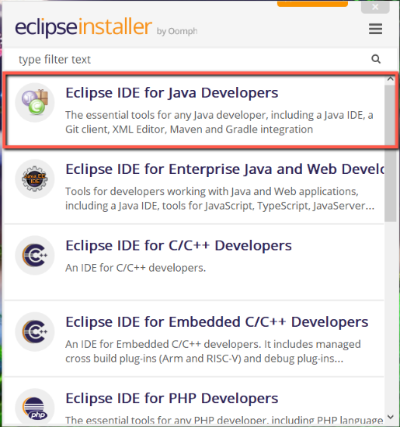

**Step 2:**

Click on install and the wait few mints.

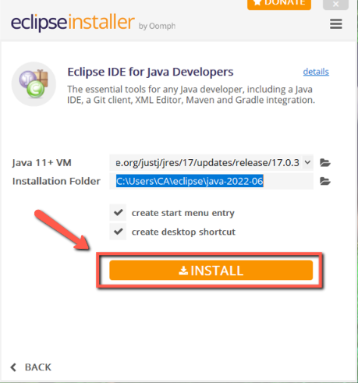

**Step 3:**

Click on Accept now.

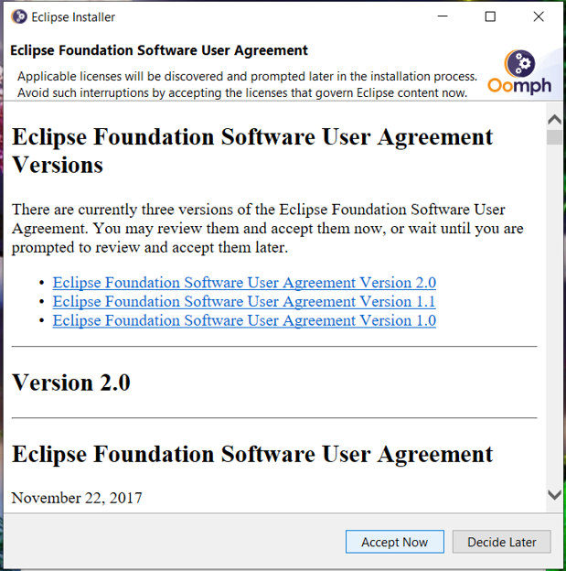

**Step 4:**

Click on Launch.

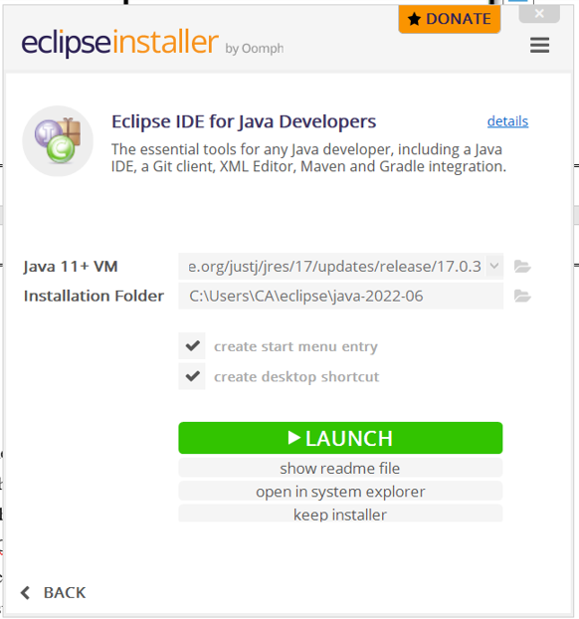

**Step 5:**

Click on Launch.

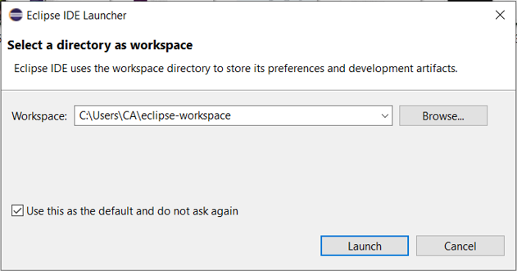

## Open and run the Test Cases

### Steps for open and run Test Cases

* Open Eclipse

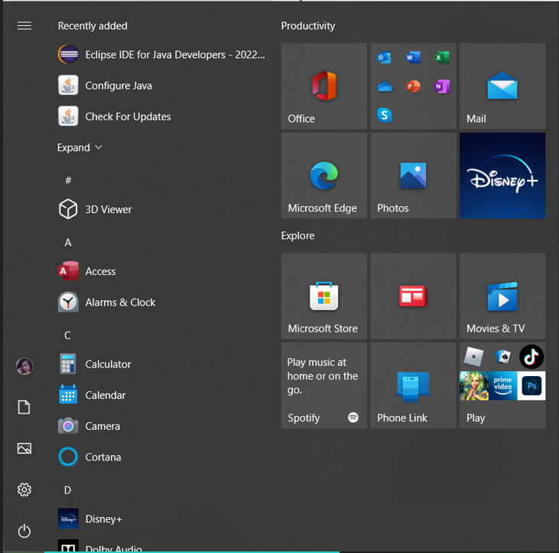

* Click on file 🡪 Open File

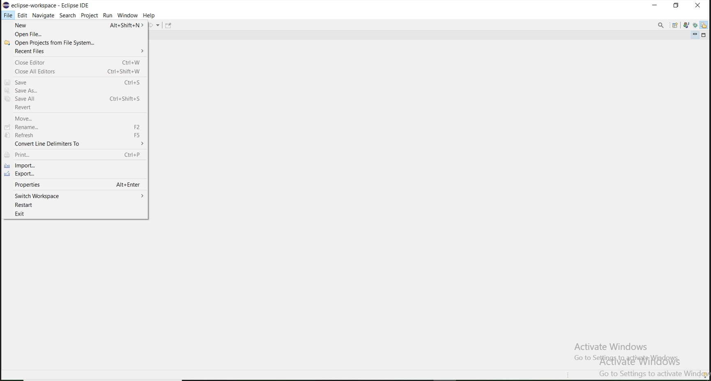

* Extract the folder 🡪 double click on Pharmaceutical 🡪 double click on Pharmaceutical 🡪 src 🡪 test 🡪 java 🡪 CucumberTest 🡪 TestRunner.java

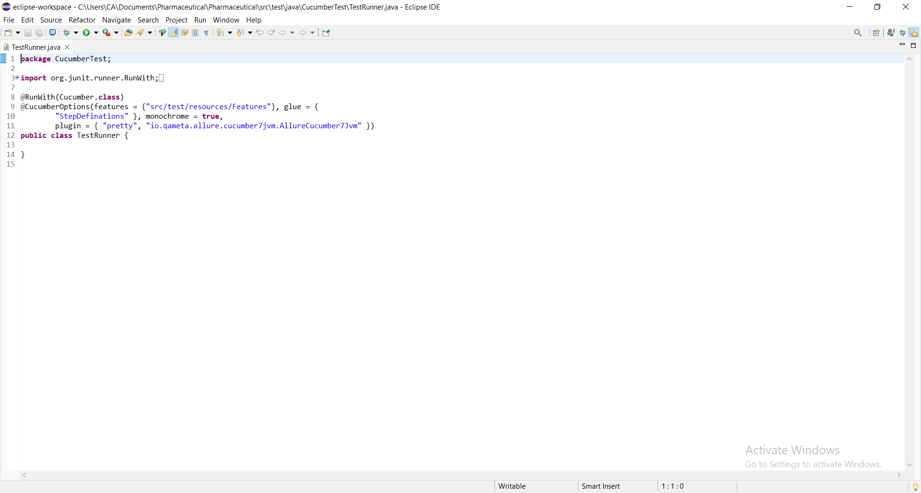

* Right click on TestRunner.java file 🡪 Run As 🡪 1 Junit Test

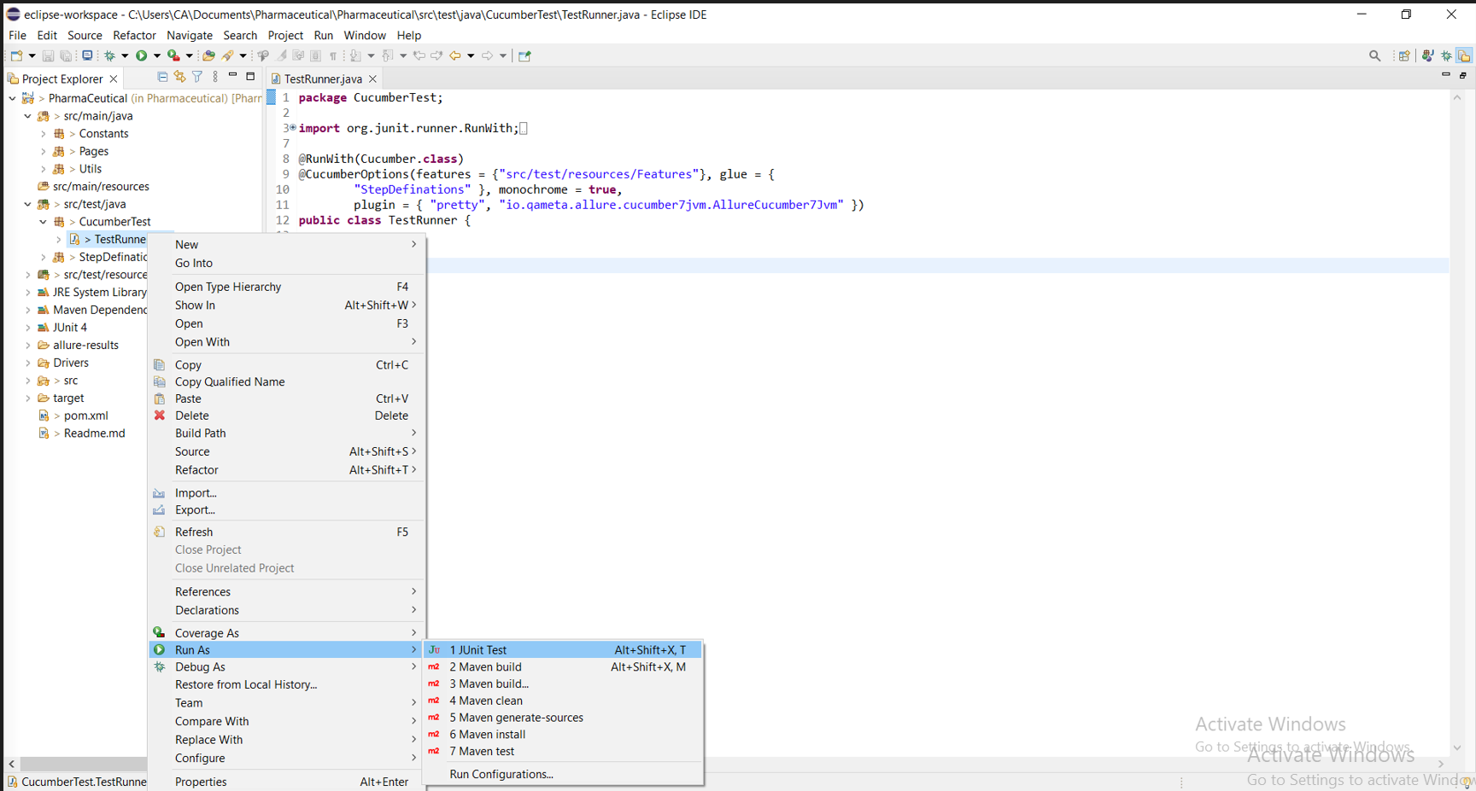

* Working Successfully.

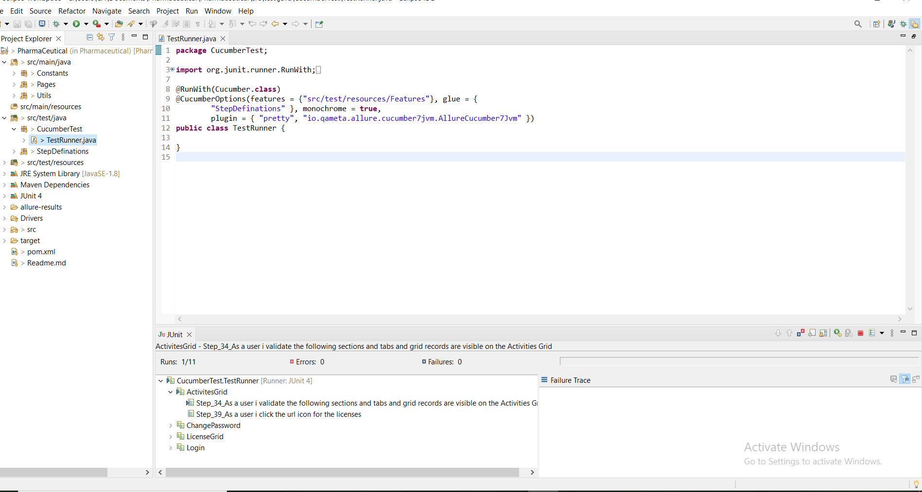

## Generate Automation Test Report

### Steps for Generate Test Report

* Open this folder (this folder has allure results folder) and copy the path from above.

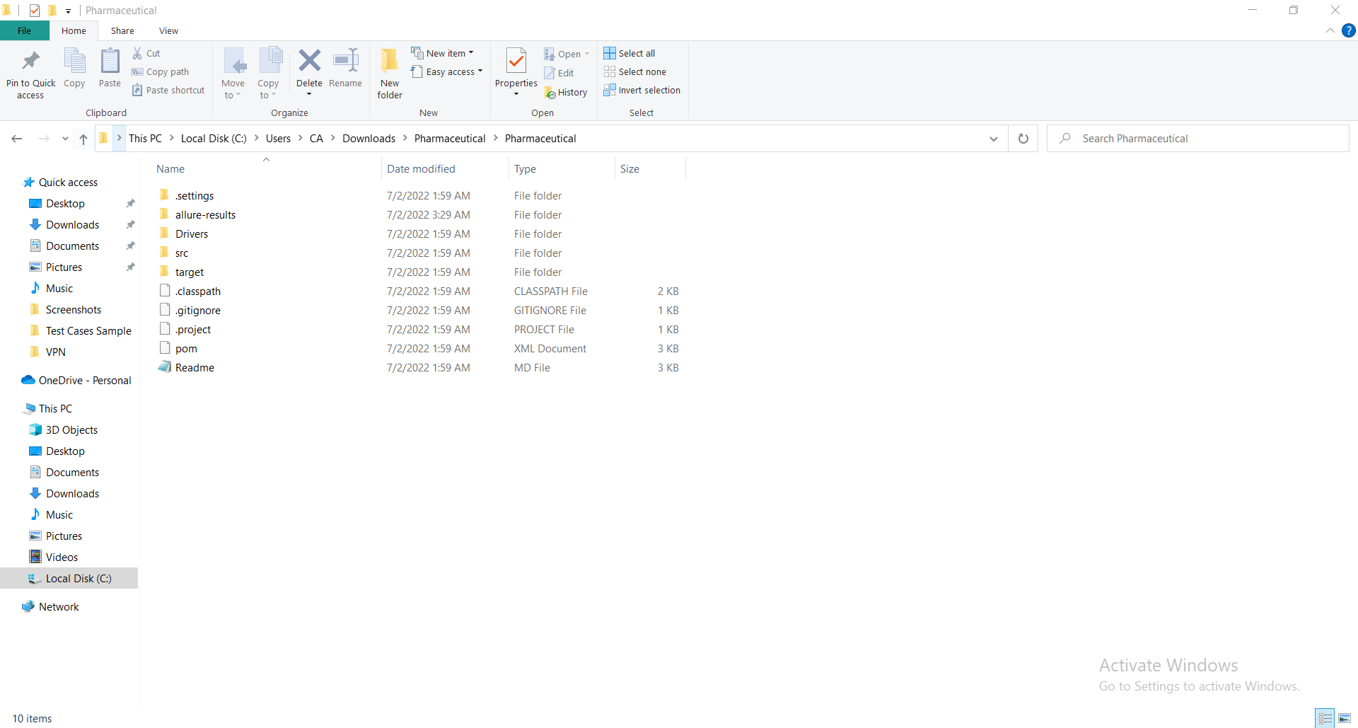

* After opening this folder open cmd. On cmd type “allure serve C:\Users\CA\Downloads\Pharmaceutical\Pharmaceutical” and press enter.

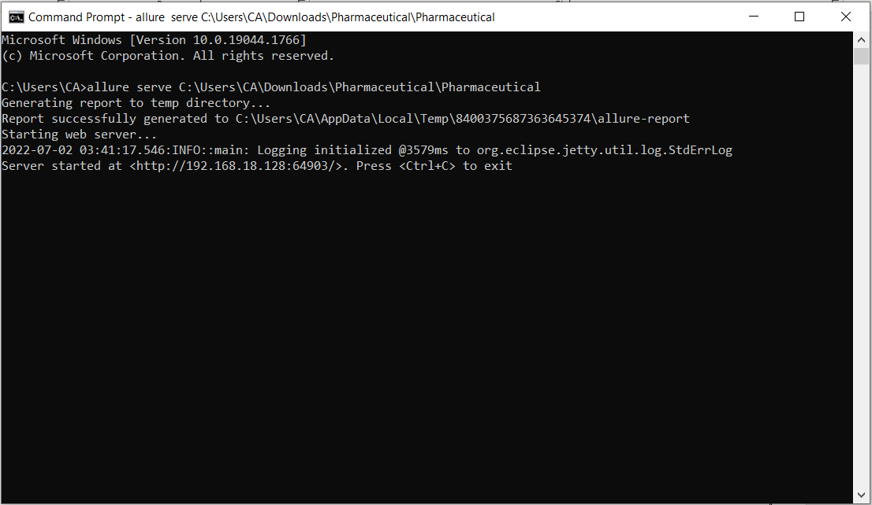

* You can see the report Here.

